

**Home Security System**

**with AWS**

**Mateusz Szalkowski**

**Bachelor of Engineering Honours in Electronic & Computer Engineering**

**2017/2018**

**Supervisor: Brian O’Shea, Galway-Mayo Institute of Technology**

**Project Poster**



**Declaration**

This project is presented in partial fulfilment of the requirements for the degree of Bachelor of Engineering in Computer & Electronic Engineering at Galway-Mayo Institute of Technology. This project is my own work, except where otherwise accredited. Where the work of others has been used or incorporated during this project, this is acknowledged and referenced.

**Acknowledgements**

I would like to take this opportunity to acknowledge and thank everyone who helped me during the creation of this project.

In my opinion, the person who deserves the most thanks for help at the key moment of this project is Ms. Michelle Lynch, lecturer at the GMIT. Thank you for all your help and support during the very difficult moments of the development phase.

I would like to thank to my supervisor Mr. Brian O’Shea, Lecturer at the GMIT.

I would also like to thank the lecturers and employees of the GMIT Electronics Department for their dedication, support and unforgettable five years during which I met many wonderful people and learned new skills. It was not always easy but sacrifice and hard work paid off and it was worth it. I have experienced many interesting moments here, and most importantly, I gained knowledge that allowed me to find a job I always dreamed about.

My adventure with GMIT is coming to an end. At the end of this path, more possibilities will appear. The experience and knowledge gained here have shown me the direction in which I hope to follow my career path.

These acknowledgements cannot be completed without mentioning the Stack Exchange team, for putting together a wonderful Q&A site for computer programming.

Finally, I would like to thank to my wife Kamila for all her help and support during development process. There are also people with whom I have established a true friendship. Our group received the nickname “Shams”. The group includes: Siddharth Raizada, David Walshe, Ronan Watkins and Daniel Wood. Thanks guys for all the fun moments spent together. I hope that we will keep in touch and continue to meet every now and then.

**Summary**

This report describes in detail the creation of a Home Security System. This project aims to detect and respond to threats such as burglaries. In the event that motion is detected, a silent alarm is triggered which activates the security camera and captures an image. The notification is sent immediately to the registered user’s mobile application along with the photo of the surroundings to verify the alarm. With positive verification, the user has a time advantage to notify the relevant authorities.

This project also includes elements of home automation, including full control of individual devices such as lighting, heating, measuring temperature and lock control. All these elements are controlled from the mobile application.

Everything works with cooperation with Amazon Web Services. It is a secure cloud service platform, that offers computing power, database storage and analysis, content distribution network and other functions that help businesses scale and grow. The main advantage of this system is it can be controlled using a mobile application from anywhere in the world. A permanent internet connection is required.

The motivation to create this project was to learn about new technologies and become familiar with the AWS cloud. In today’s world of technology, you have to follow trends and the cloud is one of them.

The system has been fully implemented, tested and presented to lecturers from the electronics department at GMIT. Work on the project will continue as a hobby, because the AWS cloud offers many other interesting services that will enhance functionality and the enjoyment of using the system.

Table of Contents

1. Introduction 8

1.1 Project Goals 8

1.2 Project Objectives 8

1.3 Project Motivation 8

1.4 Problem description 9

1.5 Problem Solution 9

2. Project Plan 10

2.1 Gantt Chart 10

2.2 Research 11

3. Architecture Diagram 12

4. Hardware Description 12

4.1 Hardware Components Schematic 13

4.2 Components List 13

4.3 Components Description 14

4.3.1 Raspberry Pi 3 14

4.3.2 Pi Camera 14

4.3.3 Temperature Sensor tmp102 14

4.3.4 PIR Motion Sensor 14

5. Cloud Description 15

5.1 AWS Cloud Services 16

5.1.1 About AWS Cloud 16

5.2 AWS elements used to create this project 16

5.2.1 AWS Internet of Things IoT 16

5.2.2 AWS DynamoDB 16

5.2.3 AWS EC2 Elastic Compute Cloud 16

5.2.4 AWS Lambda 17

5.2.5 AWS SNS Simple Notification Service 17

5.2.6 AWS S3 Simple Storage Service 17

5.3 Other Cloud Services Providers 17

5.3.1 Google Firebase Cloud Messaging 17

5.3.2 Parse Server 18

6. Software / Protocols Overview 18

6.1 Programming Languages 18

6.1.1 Python 18

6.1.2 Java 18

6.2 Communication Protocols / SDK 18

6.2.1 MQTT Protocol 18

6.2.2 Boto 3 SDK 19

7. Project Integration 19

7.1 Connecting Raspberry Pi to AWS IoT 20

7.2 Detecting motion and sending picture to AWS S3 25

7.3 Reading and sending temperature values to DynamoDB 28

7.4 Android Application 31

7.4.1 UML Class Diagram 31

7.4.2 Application Features Overview 32

7.4.3 Network connectivity check 32

7.4.4 Integration with Parse Server 33

7.4.5 Integration with AWS IoT 37

7.4.6 Retrieving temperature value from DynamoDB 40

7.4.7 Integration with Google Firebase and receiving notifications. 41

8. Conclusion 46

8.1 Problems Encountered 46

8.2 Goals achieved 47

8.3 Goals not achieved 48

8.4 Final conclusion 48

9. References 49

10. Source code 49

# Introduction

## Project Goals

The aim of this project was to build a home security system with elements of home automation that can be remotely controlled using a mobile application. All this so that the system user can remotely control household appliances, such as heating or lighting as needed. However, the most important element of the project is a silent alarm that triggers when motion is detected. This movement may suggest breaking in and in this case the reaction time is a key element in the fight against this phenomenon.

* 1. Project Objectives

Goal: Improve the protection of residential and commercial real estate and enable control of devices connected to the system via the application on the smartphone.

Objective 1: Increasing the awareness of people in all locations about the importance of home security.

Objective 2: Developing of a user-friendly security system with elements of home automation. Based on a Raspberry Pi computer, a mobile Android application and AWS cloud.

Objective 3: Delivering a working project and familiarizing with new technologies, the knowledge of which provides an advantage in the job market.

Objective 4: Improving own engineering skills acquired throughout the college.

* 1. Project Motivation

The main reason for undertaking this project was my own experience. During the holidays, someone broke into our house, searched all the rooms in order to find cash and jewellery. It was a very sad, stressful experience and it caused a lot of problems! I would not want anyone to experience a similar situation. Unfortunately, we have no influence on situations that are beyond us. Therefore, I hope that my project will help overcome this problem. It will be a great success to thwart even one attempted break in.

Another motivation was to get acquainted with AWS cloud computing services and embedded cloud elements, such as database, content delivery, computing power and other functions.

## Problem description

According to Central Statistics Office over 18 thousand [burglaries](https://www.thesun.ie/news/792266/shock-figures-reveal-18438-irish-burglaries-in-a-year-but-homeowners-are-making-it-easy-for-thieves/) occurred in just one year 2016 in Ireland. Many of these happened, because people are not taking basic steps such as setting their security alarm before going to bed, locking doors and windows or just leaving keys in the hall. Where they can be easily fished out of letter box. [Figures](http://www.thejournal.ie/summer-burglaries-3420359-Jun2017/) from An Garda Síochána show that almost one in every four break-ins from June to August involve an unsecured door or window.

According to the figures, break-ins are most likely to occur between midnight and 5am, and between noon and 3pm. Gardening equipment, tools and bikes are more likely to be stolen by thieves during the summer.

Thankfully the level of burglary crime has [dropped](http://www.thejournal.ie/burglaries-down-drink-driving-3148227-Dec2016/) by 31% in first half of 2016 according to CSO figures. Nevertheless, the problem still exists and each of us can be affected.

## Problem Solution

There may be low cost and a simple solution that can help reduce this problem. This solution will be a real-time system that can monitor the states of various sensors, including: motion, camera, temperature, lights and doors. This project has been designed to ensure the security of our assets and offers elements of home automation. All sensors have been configured and operate on the Raspberry Pi platform. This part of the project has been programmed using python language. The system user has access to all sensors and information from the Android mobile application written in Java programming language. Sensor data is processed and stored in the AWS cloud. The user has access to all stored information, such as the sensor’s air temperature, remote control of connected devices and receiving pictures taken with the camera.

All project elements with communication protocols and algorithms will be described later in this report.

# Project Plan

## Gantt Chart

The following figure shows a Gantt chart for this project with detailed tasks to be carried out to make this project a success.

Important information!

While creating this chart, there were no arrangements for the presentation or demonstration of the project yet. Some terms have been estimated in order to complete this chart.

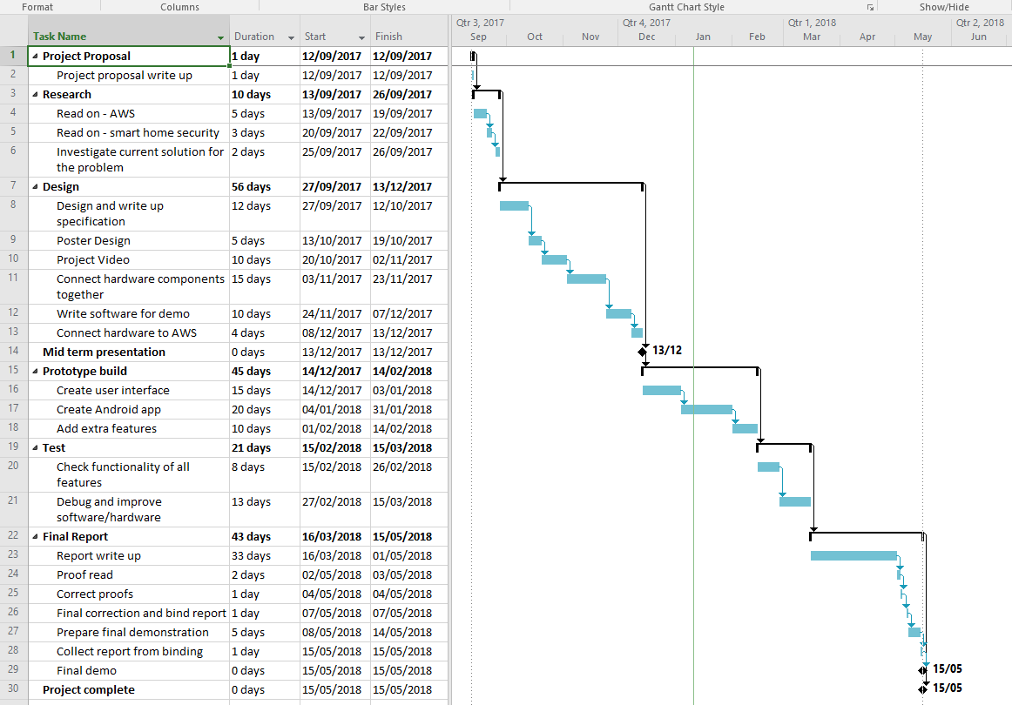

## Research

The Project was based on new cloud computing technologies and the Python programming language, which the college does not have yet in its curriculum. It was something completely new and different at the same time. Learning was demanding but it was beneficial and worth it. Nevertheless, it was an interesting experience and starting again I would choose the same project again.

AWS cloud service was chosen to create this project because after researching options from competing services, I decided that AWS is one of the largest cloud computing providers and fees and terms are very attractive. The system offers free “tier” access to key elements for twelve months. In addition, students can set up accounts for education purposes, in which the elements of the system are explained in detail. Each student can participate in online laboratories where the services are explained in detail and benefit from free credit for AWS services.

In the initial phase of the project, a lot of time was spent to get acquainted with AWS cloud services to select the right elements for building the system. The AWS documentation is very extensive and describes in detail all services and protocols. In some cases, it provides examples of how to implement, run and combine certain elements.

A thorough analysis of architecture and specifications was carried out for Raspberry Pi hardware and sensors. On this basis, the appropriate elements were selected to create the project. Some parts of it were used in cooperation with existing elements created by other people. These elements will be referenced in this section of the report.

The Android application was written at the final phase of the project. This was not the first contact with Android, because in the ninth semester we discussed and practiced the programming of mobile devices.

I tried to solve all problems encountered in the process of creating a project myself. In some cases, I used tutorials and similar examples from various different sources like: AWS documentation, youtube.com, stackoverflow.com or udemy.com

# Architecture Diagram

This architecture diagram was created with the intention of matching it to the project poster on which the element of the comic is presented.

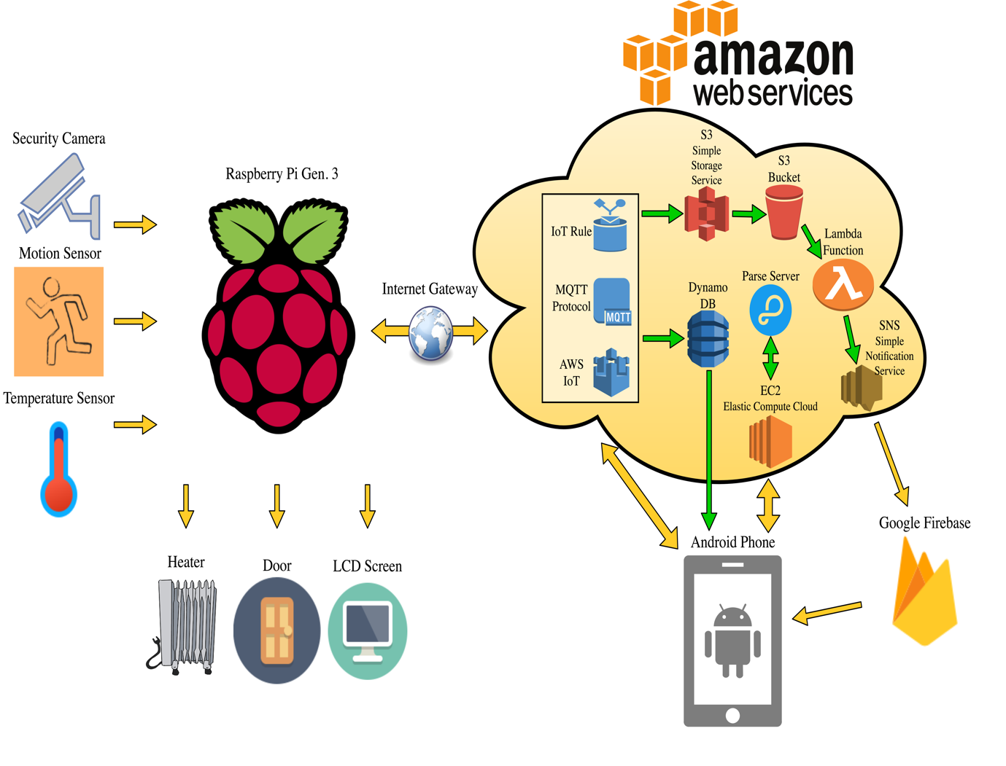

# Hardware Description

The project focuses mainly on cloud technology, setting it up and writing software to support a mobile application. The hardware was only used as an add-on and will be described briefly. This section discusses the basic elements used to create a project without going into individual communication protocols between them or datasheets of individual components. The reason for this decision is that it has already been thoroughly discussed and understood while studying electronics during previous years of the course. Understanding at this level should be obvious and should not require additional documentation and explanations. This report is focused on the software side of the project and only a basic level of electronics documentation is provided.

## Hardware Components Schematic

The following picture shows the actual wiring diagram of the design elements.

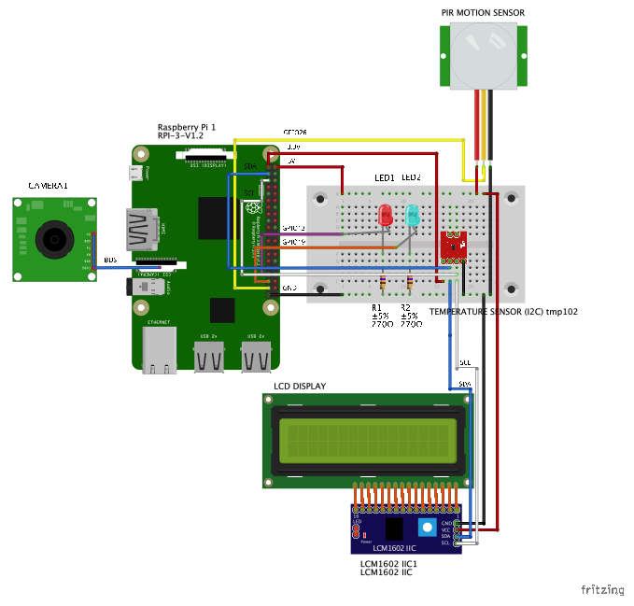

## Components List

* Raspberry Pi 3 Model B
* Pi camera
* 16x2 LCD screen with LCM1602 I2C
* Temperature sensor tmp102 I2C
* PIR motion sensor
* LED x2
* Resistor 270R x2

## Components Description

### Raspberry Pi 3

Raspberry Pi is currently one of the most popular single board computer platform - SBC that has won the hearts of many users around the world. It was created by the Raspberry Pi Foundation to promote the teaching of basic computer science in schools and developing countries.

The launch of the original model took place on February 29, 2012. And it became much more popular than expected, selling outside of its original target market for uses such as robotics.

The latest version of the popular minicomputer distinguishes by the more powerful quad-core Broadcom processor. In addition, the SoC has 1GB of RAM, built-in Wi-Fi and Bluetooth 4.1 and four USB ports, 40 GPIO, microSD card connector, Ethernet port and four mounting holes. This configuration makes it the cheapest, complete computer in the world. No wonder it has gained popularity among hobbyists and enthusiasts.

### Pi Camera

The Raspberry Pi camera module can be used to take high-definition video, as well as still photographs. It connects to a dedicated Camera Serial Interface – CSI. The device has a sensor with a resolution of 8 Mpix, supports HD 1080p, 720p and 640 x 480p. It can take pictures in higher resolution 3280 x 2464 px. Configuration takes place in a simple and user-friendly way.

The camera module is very popular in home security applications, and in wildlife camera traps.

### Temperature Sensor tmp102

A small module with a TMP102 digital temperature sensor with a resolution of 0.0625°C and accuracy of 0.5° C. The device communicates via the I2C bus, the module does not contain a built-in voltage regulator, so the supply voltage should be between 1.4 and 3.6 V. the module contains filtering capacitors and pull-up resistors.

### PIR Motion Sensor

PIR motion detectors, known as passive infrared detectors, constitute a basic element of internal protection of burglary and assault signalling systems. Passive infrared detectors work on the principle of detecting changes in infrared radiation from the infrared range using a pyroelectric sensor whose electrical signal is analysed by a special electronic detector system. Due to the fact that such detectors are not able to operate without the need to generate their own energy, they are called passive. This type of device does not emit its own energy, but only detects any changes in infrared radiation in their field of view. When motion is detected the PIR sensor outputs a high signal on its output pin.

**Features**  
• Detect a person up to - 30 ft. away, or up to 15 ft. away in reduced sensitivity mode  
• Jumper selects normal operation or reduced sensitivity  
• Source current up to 12 mA @ 3 V, 23 mA @ 5 V  
• Mounting holes for 2-56 sized screws  
• 3-pin SIP header ready for breadboard or through-hole projects

# Cloud Description

The cloud is one of the trends that is developing most dynamically in the world of broadly understood IT.

A few words about the cloud:

The cloud can be defined in two ways. The first is cloud computing, the second is public clouds or disks in the cloud offered by the largest IT industry leaders, independent companies or organizations and manufacturers of equipment, computers, smartphones, tablets and even telecommunications companies. Public cloud is often used by home users who want to protect valuable data from loss or damage. Almost all of us have experienced the loss of photos taken during holidays or important documents, e.g. due to damage to the hard drive. A few years ago, there was no other way to secure our data, apart from an additional external disk. Today, we have the ability to store our valuable data, even in encrypted form in many different cloud services. But do we all use it?

On this, let’s leave the topic of public clouds and get to the point related to the theme of this project. Namely, cloud computing, because there is a lot of potential in them.

Cloud computing is a kind of model for providing a service based on the supplier’s external infrastructure. The cloud in this release is a collective concept and as part of it functions as a platform for specialized analytical software, information systems or applications that we use for many years in offline versions. Examples? Complicated Enterprise Resource Planning Systems – ERP can run in the cloud, enabling managers to view company data from a desktop computer and a smartphone. And for private users? Do you use word processors or programs such as Microsoft PowerPoint? Their online counterparts are based on cloud infrastructure, thanks to which we can write and send multimedia presentations using devices that do not have an official application installed.

## AWS Cloud Services

### About AWS Cloud

Most people see Amazon as the company that runs the largest online store. For Amazon entrepreneurs, however, it is increasingly a warehouse that provides cloud infrastructure for rent.

Amazon Web Services (AWS) is a network of services and servers, data processing technology and Amazon virtual machines.

AWS, interestingly, was created by the fact that Amazon wanted to earn from the power surpluses of its server farms, as the company has its own servers to maintain its services. AWS allows companies to transfer their own data centres, providing a high quality environment for scaling and maintenance, but also security and relatively low prices, i.e. Lower than If the company itself wanted to create and manage its own server room.

## AWS elements used to create this project

### AWS Internet of Things IoT

AWS IoT (Amazon Internet of things) enables connected devices to easily and securely interact with applications in the cloud and other devices. AWS IoT can handle billions of devices and trillions of messages, and process and route them to AWS endpoints and other devices in a reliable and secure manner.

AWS IoT allows you to easily connect devices with cloud and other devices. It supports HTTP, WebSockets and MQTT. MQTT is a lightweight communication protocol, specifically designed to tolerate intermittent connections and reduce network bandwidth requirements. MQTT was chosen as the main protocol to build this project and will be described later in this report.

### AWS DynamoDB

Amazon DynamoDB is a NoSQL database for all applications that need a fixed, single digit millisecond latency at any scale. It is a fully managed cloud database and supports both document and key- value store models. All you need is to create tables and send data without worrying about servers or storage. It’s flexibility, reliability and automatic scaling of throughput makes it perfect for gaming, web, IoT, mobile and many other applications.

### AWS EC2 Elastic Compute Cloud

Amazon EC2 is so-called “Elastic Cloud”, a virtual infrastructure which allows allocation of computing capacity, running in the cloud. Allows to run and test applications in the cloud on Windows and Linux. It is worth noting that thanks to this tool developers can program using virtually any popular programming language.

### AWS Lambda

An alternative to AWS EC2 is AWS Lambda. The tool is able to execute the written code without first defining the required computing power by the user. This is done automatically, based on the requirements of the application itself. Fees for this solution depend on the total time you use the resources. Solutions created on the basis of AWS Lambda can be written in such languages as Python, C#, GO, Java and Node.js.

### AWS SNS Simple Notification Service

AWS SNS a cloud service for coordination the delivery of push messages from the applications to subscribed endpoints and clients. This service allows users to forward messages to Windows, Google, Apple and some smart devices connected to the internet through the Application Programming Interface - API. After the message is published in the service, it can be sent many times to different recipients.

### AWS S3 Simple Storage Service

AWS S3 is short for Simple Storage Service and is a mass storage service offered by Amazon Web Services. Its main task is the ability to store and easily access any amount of data. S3 can be used independently, in cooperation with other Amazon Web Services or even with third party programs.

It is most often used for:

* Backup and archiving
* Big Data analysis
* Content storage and distribution
* Disaster recovery
* Hosting static files (e.g. photos)

## Other Cloud Services Providers

### Google Firebase Cloud Messaging

Firebase Cloud Messaging is a free Google service that allows you to send messages between any server application and mobile applications. Provides support for Android, iOS and Chrome web applications. FCM is the successor of Google Cloud Messaging – GCM.

FCM acts as an intermediary between a Firebase server or console and a mobile application. Notifications sent to the Google cloud are then queued and redirected to specific devices. The Google service allows you to send messages to a specific device, to all devices (broadcast) or to devices subscribing to a given topic (group).

The FCM integration consists of three simple steps:

1. Create a Firebase project and link to the client application
2. Subscribing to a given channel and handling messages in a mobile application
3. Implementation of a server part

### Parse Server

PARSE is BaaS – Backend service platform (Backend as a service). With PARSE, developers can add a scalable backend in a few minutes and instantly launch a fully functional mobile or web application, without worrying about server management. PARSE offers notification functions, social integration, data storage, and provides a wide range of solutions for user management to the backend of your application using the Cloud code.

# Software / Protocols Overview

## Programming Languages

### Python

Python was chosen as the main language to program the Raspberry Pi platform. It’s task is to communicate with the cloud, read information from sensors and make decisions based on data.

Initially, the project was to be written only in Java. It was at the beginning of the project, where the knowledge of AWS architecture was almost nil. Examination of the documentation and attempts to run the sample program failed. After a few days without a result, it was decided to look for an alternative. In the meantime, there was a job offer that uses Python. This was taken as an opportunity to learn something new, which is probably useful when performing tasks in a new job.

### Java

Java has been used to program the mobile application on the Android. At present, this is a native language for programming on this platform. Although this trend is changing, and everything indicates that in the near future Java will be replaced by Kotlin.

## Communication Protocols / SDK

### MQTT Protocol

MQTT Protocol (Message Queue Telemetry Transport) is a light data transmission protocol. It was created in 1999 by Andy Stanford-Clark (IBM) and by Arlen Nipper (Eurotech). Based on the Publish-Subscribe pattern (topic-based), it enables communication between via an intermediary server. Due to the ease of use, low demand for hardware and network resources it has become a key protocol used in IoT (Internet of Things).

Applications:

The MQTT protocol uses, among others Facebook Messenger, Amazon in the AWS IoT service and the broadly understood field of medicine, e.g. during radio communication with pacemakers. Of course, these are only selected examples of applications.

In this project, the MQTT protocol was used to exchange messages between mobile application and storing temperature sensor measurements to DynamoDB database.

Publish-Subscribe System

MQTT is based on the Publish-Subscribe pattern. In this architecture, messages sent by senders (publishers) are sent to the intermediary server (the broker), and not directly to the recipients (subscriber). This pattern is one of the integration patterns.

The recipient receives messages that he is actually interested in, does not know anything about its sender. The sender also does not know which recipient will receive the message. It is also not known whether someone will receive a message at all.

With this communication solution, there is no so-called pooling, i.e. cyclic querying of the server or new data appeared (query => answer). It can be said that the concept was reversed by 180 degrees and the server will inform interested clients about the new message.

As the implementation of MQTT is based on topic-based, this means that the message is published on the so-called (topic). Customers who subscribe to a given topic receive messages posted on it. It is worth noting that when broadcasting messages there’s no need to worry about whether a given subject exists – there is no such thing as topic management (creation/deletion), we just send data.

### Boto 3 SDK

Boto 3 is the Amazon Web Services (AWS) Software Development Kit (SDK) for Python. It allows Python developers to write software that uses services such as Amazon S3 and amazon EC2. In the case of this project, it was used to upload photos to Amazon S3. the full example along with the description is available in the Project Description section.

# Project Integration

This part of the report chronologically describes all the important steps necessary to establish a connection between Raspberry Pi, Amazon AWS cloud and the mobile application. Also described are the components of the software, which operation of some elements requires explanation as well as decisions and thoughts during the creation of algorithms. Code snippets will be included and described where required.

The AWS account registration step will be skipped because it is fairly simple and straightforward.

## Connecting Raspberry Pi to AWS IoT

The individual steps will be discussed in this section. The AWS documentation describes in detail how to establish connection and represent all necessary steps to connect devices. A link to this documentation will be included in the references section.

One of the first step required was to register a “thing”. The “thing” is a device that we want to connect to the cloud. To do this, you must log in to the IoT console from <https://aws.amazon.com/iot> and select Manage from the left navigation panel.

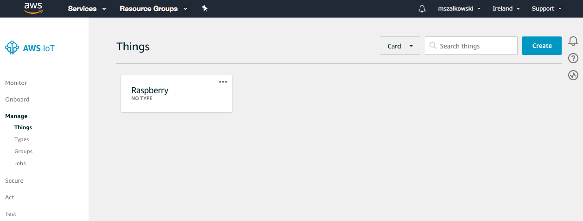

The picture above shows the AWS IoT console that has already configured the Raspberry Pi device. To add a new device, click Create and follow the wizard’s instructions. After creating and registering new device, select Interact and make a note of the REST API endpoint. This will be required later.

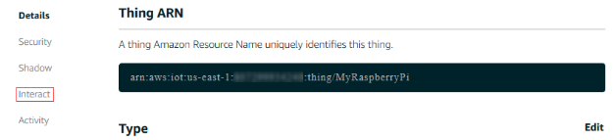

The next step was to create the certificates. They are used to connect “things” to the cloud. If the certificate does not pass verification, communication will not be possible. From security panel choose Create Certificate. This generates an X.509 certificate and key pair.

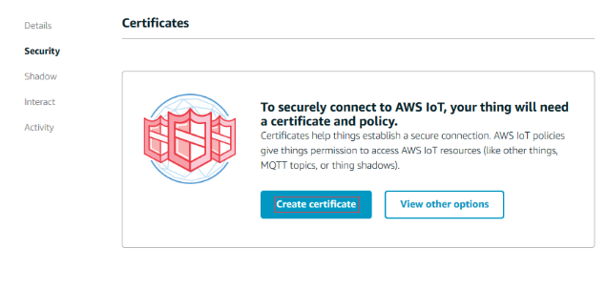

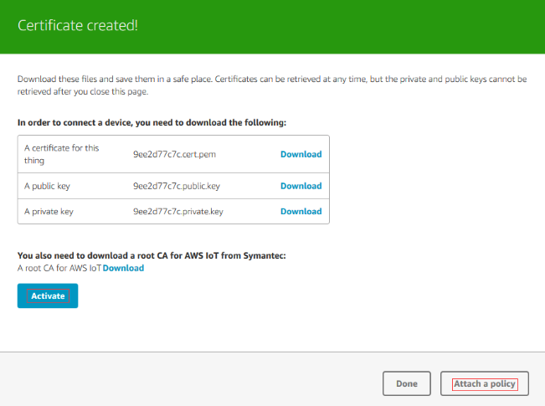

Download the generated certificates and save on the target device. Next click Attach a policy. This parameter allows you to specify what access rights the device has, e.g. can it read and write or just read. In this case, we allow all actions related to IoT.

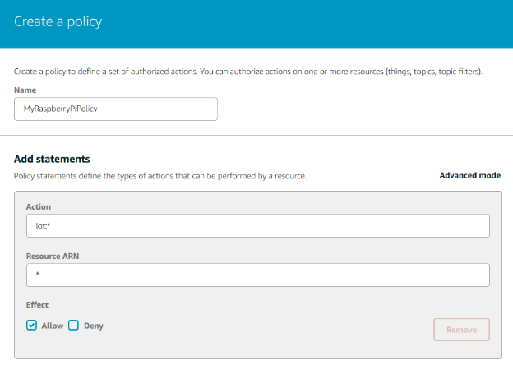

The final step in the cloud configuration is to add policy and a “thing” to the certificate.

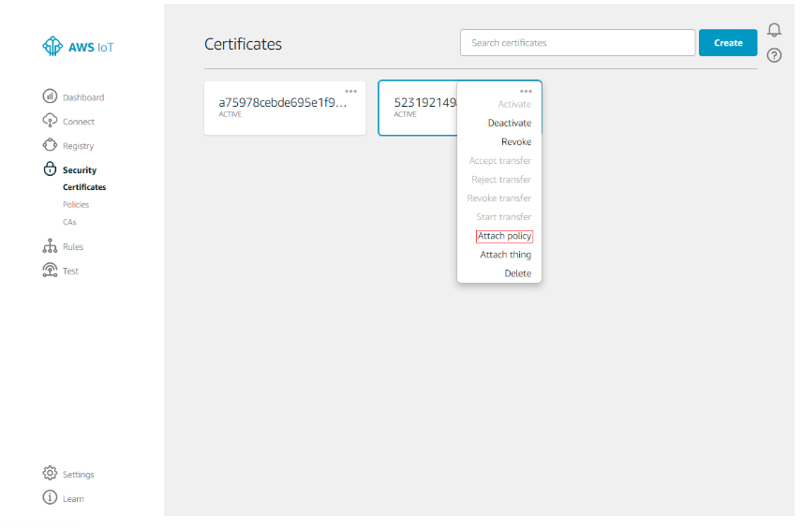

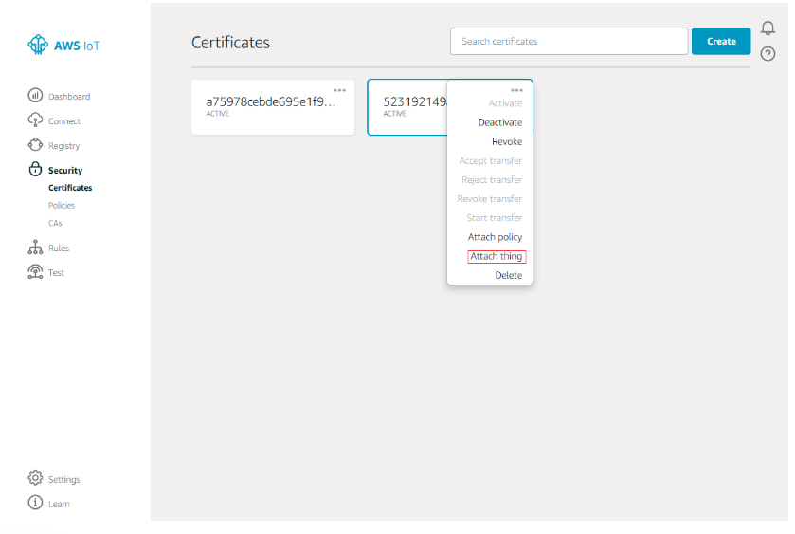

The above steps described the required actions for the IoT setup. The configuration of the device “thing” and steps required to obtain the connection will be described below [1].

The language used to program Pi is Python.

The created certificates and endpoints should be read from the file to ensure safety when using Version Control Systems VCS like GIT or others. The following code shows the solution used in this project.

# read certificates required for authentication

rootca = r'/home/pi/Desktop/pythonForAWS/certs/rootCA.pem'

certificate = r'/home/pi/Desktop/pythonForAWS/certs/certificate.pem.crt'

keyfile = r'/home/pi/Desktop/pythonForAWS/certs/private.pem.key'

hostName = open("/home/pi/Desktop/pythonForAWS/certs/hostName.txt", "r")

The following snippet is responsible for defining a new MQTT topic, creating an object and passing the certificates and endpoint to constructor to establish connection with the cloud. This is the minimum required for communication with AWS via the MQTT protocol. In this case the code is quite simple and does not require explanation. Note that the code starting with the word “def” represents the beginning of the function. The hash “#” symbol represents comments.

# define IoT mqtt topics

topic_iot = "mytopic/iot"

# import AWS IoT MQTT library

Librarycheck = True

try:

import paho.mqtt.client as mqtt

except ImportError:

Librarycheck = False

print("paho-mqtt python package missing...")

# setup connection, try to connect and wait for incoming messages

c = mqtt.Client()

c.tls_set(rootca, certfile=certificate, keyfile=keyfile,

cert_reqs=ssl.CERT_REQUIRED, tls_version=ssl.PROTOCOL_TLSv1_2, ciphers=None)

# the callback for when the client receives a response from the server

def onc(c, userdfata, flags, rc):

print("successfully connected to Amazon with RC ", rc)

c.subscribe(topic_iot)

# the callback for when a publish message is received from the server

def onm(c, userdata, msg):

print(m)

c.connect(hostName.read(), 8883)

sleep(2)

c.loop_start()

c.on_connect = onc

c.on_message = onm

# main function

try:

while True:

# run this loop forever

sleep(1)

# if CTRL-C is pressed the main loop will break and connection will terminate

except KeyboardInterrupt:

print("Exitting")

finally:

c.loop_stop()

c.disconnect()

print("Connection terminated")

To perform the test, you must log in to the IoT console. Select the test from the navigation panel and subscribe to the topic: mytopic/iot. After Subscribing, you can send messages to Raspberry Pi. Please see screenshots below. The first picture shows the sent message from the console, the second picture shows the message received in the Raspberry Pi terminal. Each message can be easily read, analysed and used to control devices or events.

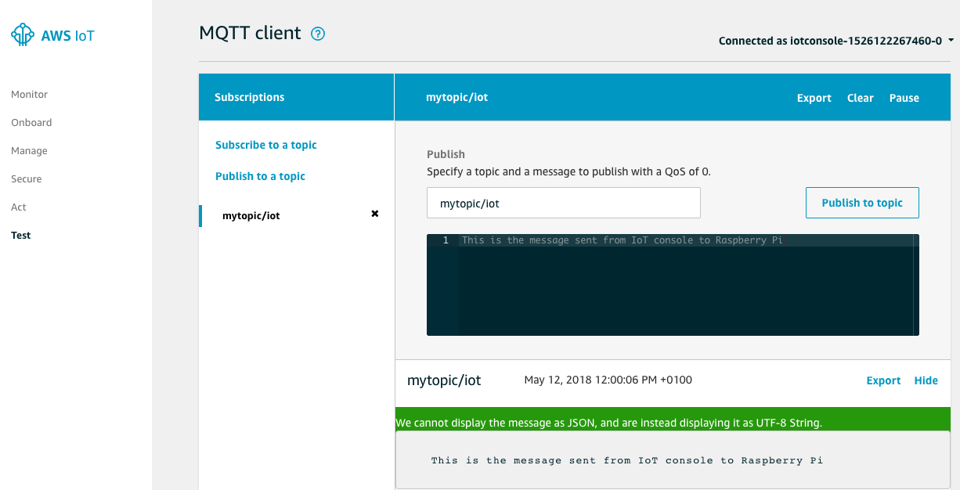

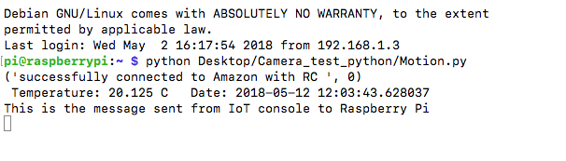

## Detecting motion and sending picture to AWS S3

Initially, this part of the project has been accomplished locally, pictures were saved on the Raspberry Pi device. At the later stage, the ability to send photos to the S3 container was added. The configuration of the Pi camera with the Raspberry device will be omitted because it is a quite an easy and fast process and does not require explanation.

The main elements of this part included: motion sensor, Pi camera, algorithms and libraries supporting them. The motion detector was configured as an interrupt using General Purpose Input Output GPIO. Each call triggered the camera by taking a photo, storing it locally and transferring to the S3 container. This operation was performed as a new thread, to prevent system from failing.

This feature required subsequent configurations and obtaining new certificates needed to establish a connection with the S3. Below is the minimum code that describes the steps required to configure devices and the cloud.

# all required imports (send_file is a file, containg store_to_bucket function)

from send_file import store_to_bucket

from threading import Thread

import time

import datetime

import picamera

import RPi.GPIO as GPIO

# define gpio pins (board mode)

pir_sensor = 37

# setup gpio ports

GPIO.setwarnings(False)

GPIO.setmode(GPIO.BOARD)

GPIO.setup(pir_sensor, GPIO.IN, pull_up_down=GPIO.PUD_DOWN)

# get camera instance

camera = picamera.PiCamera()

# function to detect interrupt event.

def my_callback(channel):

print("Event detected on pir sensor")

take_snap()

# function to take a snapshot and save in specific folder.

# date_string is used to take a picture and add current date as a name to prevent image duplication. Store_to_bucket is called as a new thread with two parameters: path to picture and date.

def take_snap():

print("Taking snap\n")

date_string = time.strftime("%m-%d-%H-%M-%S")

path = '/home/pi/Desktop/Camera_test_python/pictures/'

date = 'image'+date_string

ext = '.jpg'

full_path = path+date+ext

# save camera picture locally and pass location to store2bucket function

camera.capture(full_path)

# create new thread, store to bucket is a function called from other file

try:

thread.start_new_thread(store_to_bucket, (full_path, date,))

except:

print("Error: unable to start thread")

# setup interrupt service routine when pir sensor state changed detected.

GPIO.add_event_detect(pir_sensor, GPIO.FALLING, callback=my_callback)

Below is the content of a separate file containing keys and certificates required to establish connection with S3. After reading the keys, the connection to S3 is made and the photos are sent to the container.

import boto3

from botocore.client import Config

# reading all credentials

ACCESS_KEY_ID = open("/home/pi/Desktop/pythonForAWS/certs/key.txt", "r").read()

ACCESS_SECRET_KEY = open("/home/pi/Desktop/pythonForAWS/certs/skey.txt", "r").read()

BUCKET_NAME = open("/home/pi/Desktop/pythonForAWS/certs/bucket.txt", "r").read()

# function to read passed arguments and converting to required form for storage ‘rb’ stands for read binary

def store_to_bucket(path, date):

data = open(path, 'rb')

ext = '.jpg'

s3 = boto3.resource(

's3',

aws_access_key_id=ACCESS_KEY_ID,

aws_secret_access_key=ACCESS_SECRET_KEY,

config=Config(signature_version='s3v4')

)

s3.Bucket(BUCKET_NAME).put_object(Key=date+ext, Body=data)

print ("Done")

The last part of implementing this function was to create the S3 bucket. The following text describes the configuration of the container and the generation of security keys.

Login to the Amazon console and open the Amazon S3 console. Select Create bucket and follow the wizard’s instructions. then you will need to set the bucket name, which must be unique among all buckets available on the network. Another important element of creating a bucket is setting the access rights. For this project, only the owner of an AWS account can save items. Everyone has an access to them, provided they know the name of the bucket. This step is required in the later part where photos are sent to the mobile application. After configuring all settings, you should see a similar screen with a list of all buckets and basic information about the access.

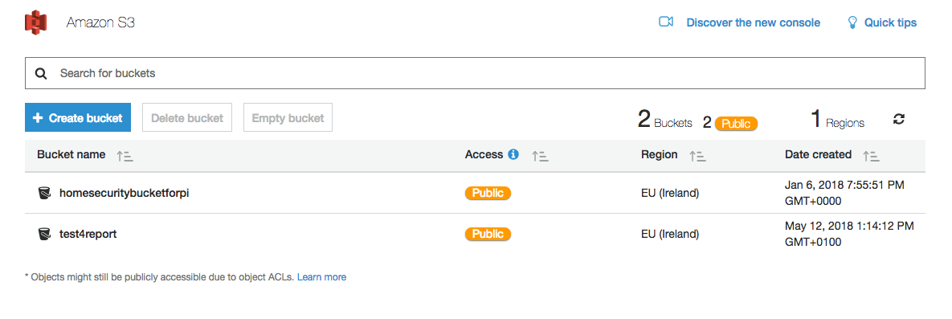

The next step is to get the verification keys needed to send data from devices to S3 container. In this case a new user has to be created in the Identity and Access Management IAM console. Once account is created, it is required to add the write permission to the S3 bucket. On success, you should have access to the security keys. Download the keys and save then on device. The procedure of sending the pictures including code fragments has been described earlier.

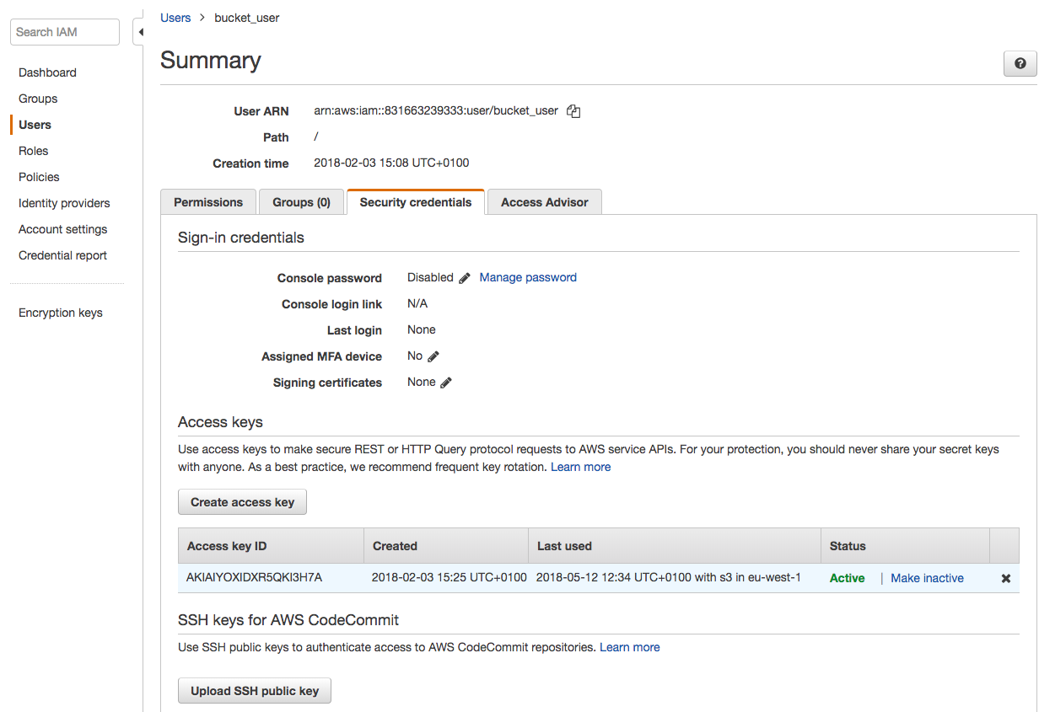

## Reading and sending temperature values to DynamoDB

This section describes the procedure for reading the temperature and saving it in the DnamoDB database. This part of the project uses the temperature sensor tmp102 on the serial data transfer bus I2C.

To read the data and interface to the sensor, I used the algorithm created and shared by the user Feodor Hilitski. The link will be available in the references section [2].

The following snippet shows the minimum complete code along with the changes introduced by me to improve functionality. Some parts of the following code had already been discussed. If any part is unclear, read the sections above.

# all required imports

import pigpio

import thread

from threading import Thread

import RPi.GPIO as GPIO

import time

from time import sleep

# a time delay for temperature database store interval

delay_temp = 2

# read certificates required for authentication

rootca = r'/home/pi/Desktop/pythonForAWS/certs/rootCA.pem'

certificate = r'/home/pi/Desktop/pythonForAWS/certs/certificate.pem.crt'

keyfile = r'/home/pi/Desktop/pythonForAWS/certs/private.pem.key'

hostName = open("/home/pi/Desktop/pythonForAWS/certs/hostName.txt", "r")

# i2c bus of Pi 3

i2c_bus = 1

# address devices on the i2c bus

tmp_sensor_addr = 0x48

dev_pi = pigpio.pi()

dev_tmp = dev_pi.i2c_open(i2c_bus, tmp_sensor_addr , 0)

register_n = 0

# define IoT mqtt topics

topic_tmp2 = "mytopic/iot/temp_read2"

# setup AWS IoT

Librarycheck = True

try:

import paho.mqtt.client as mqtt

except ImportError:

Librarycheck = False

print("paho-mqtt python package missing...")

# setup connection, try to connect and wait for incoming messages

c = mqtt.Client()

c.tls_set(rootca, certfile=certificate, keyfile=keyfile,

cert_reqs=ssl.CERT_REQUIRED, tls_version=ssl.PROTOCOL_TLSv1_2, ciphers=None)

The above code is needed to configure I2C serial bus, setup the connection to the MQTT protocol and read all necessary keys.

The following function is used to read the temperature from the register, process it to the appropriate format and send it to the database. The function works on a new thread in the background. The temperature is sent in JSON format as the key / value pair in which the following information is saved: current time in the for of milliseconds from the epoch and temperature value. After this, you can easily sort and download the latest temperature value stored in the database on the mobile application.

# calculate temperature based on the first word and the first byte

def tmp_reading():

try:

count = 0

while True:

count += 1

t_byte = dev_pi.i2c_read_byte_data(dev_tmp, 0)

t_word = dev_pi.i2c_read_word_data(dev_tmp, 0)

l4b = ( t_word & 0b1111000000000000)>>12

temperature = ((t_byte<<4) | l4b) * 0.0625

timestamp = datetime.datetime.now()

millis = time.time()

msg = '"Millis": "{}", "Temperature": "{}"'.format(millis, temperature)

msg = '{'+msg+'}'

c.publish(topic_tmp2, msg, 1)

time.sleep(delay_temp)

except KeyboardInterrupt:

pass

# on connection send a message to console

def onc(c, userdfata, flags, rc):

print("successfully connected to Amazon with RC ", rc)

c.subscribe(topic_heat)

# start temperature read thread

background_thread = Thread(target=tmp_reading, args=())

background_thread.daemon = True

background_thread.start()

# main function

try:

while True:

# run this loop forever

sleep(1)

# if CTRL-C is pressed the main loop will break.

except KeyboardInterrupt:

print("Exitting")

finally:

GPIO.cleanup() # reset ports

c.loop_stop() # start connection loop

c.disconnect()

r = dev_pi.i2c_close(dev_tmp) # close i2c devices

print("Connection terminated"

The next part of this section will discuss the database configuration process. It will be an introduction to key elements. The exact configuration and all additional options are discussed in the documentation. The following figures shows the DynamoDB console with a list of all created tables. Only Temp2 table is used in this project. The rest was created for educational purposes. As you can see in the image, the primary partition key is time in milliseconds and the primary sort key is the temperature value. Everything is retrieved from the incoming JSON message in MQTT. This requires creating a rule in the IoT console and adding new permissions to allow the data to be read by the database.

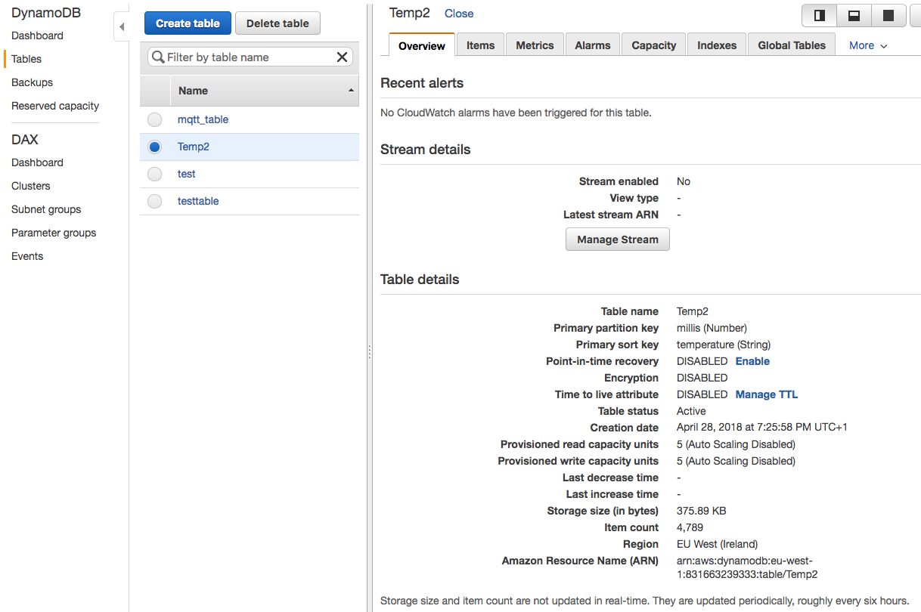

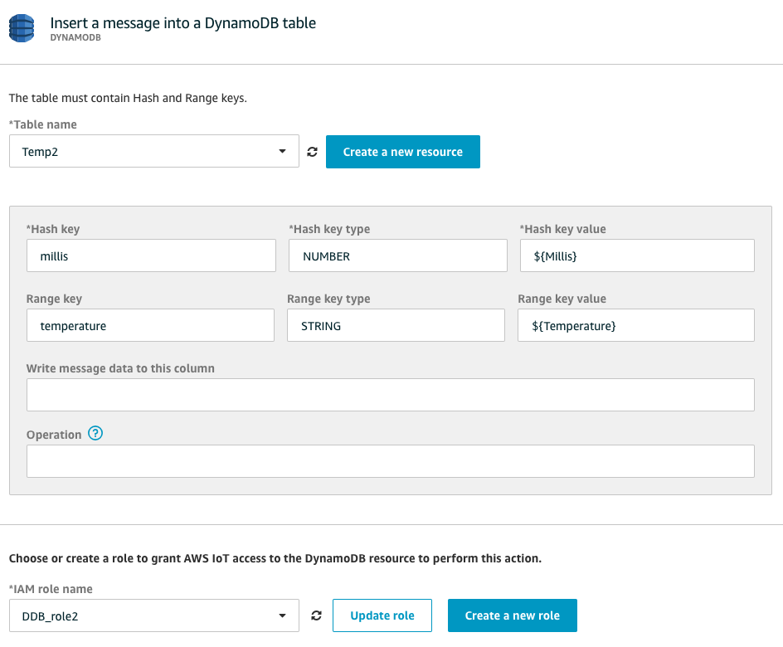

## Android Application

### UML Class Diagram

The following figure shows the UML diagram of the mobile application.

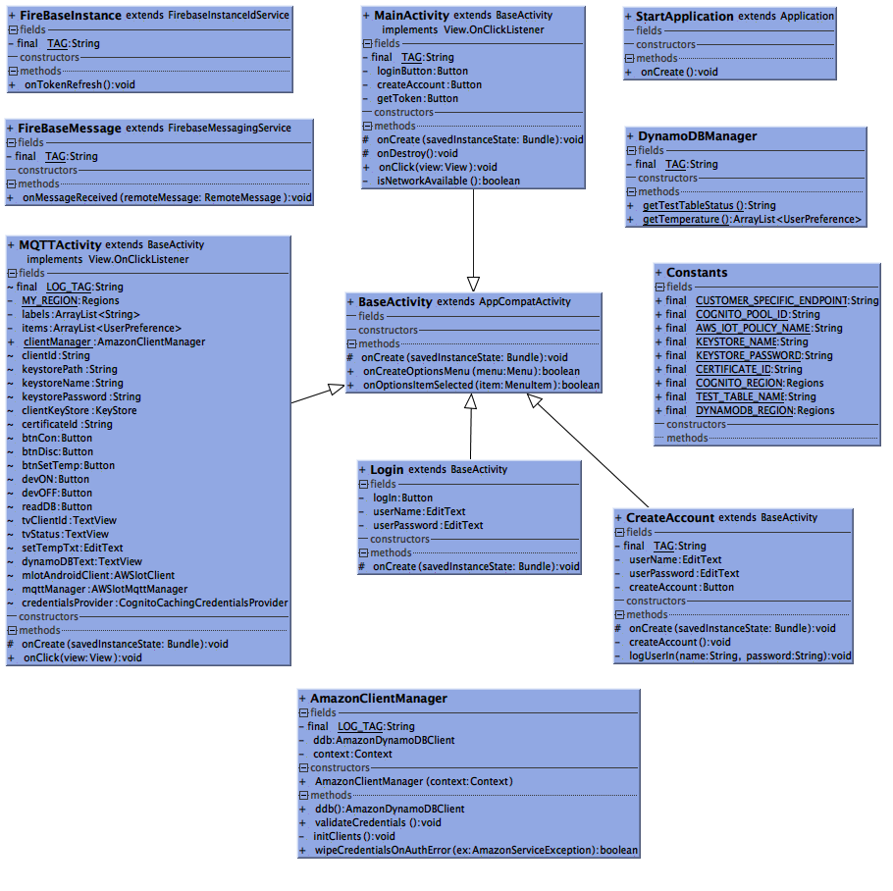

### Application Features Overview

This section aims to create a list of all important functions of the mobile application. The next part of the report will describe the most important functions and algorithms used to create this application.

Application features:

* Internet connectivity check
* Option menu on each activity (About App, Exit App, Restart App)
* Integration with Parse Server (Backend running on EC2 instance, used to create user account and verifying existing users)
* Integration with AWS IoT console
* Ability to control devices connected to Raspberry via MQTT protocol
* Possibility to query database and pull latest temperature values from the sensor connected to Raspberry
* Possibility of sending the temperature to the Raspberry heating system
* Receiving notifications from Google server
* Receiving photos from the S3 bucket

### Network connectivity check

Almost all professional mobile applications working online check the network connection before the start. It is a very good practice to follow this trends.

Android has a very simple and easy to use connection manager that checks whether our smartphones are connected to the network. When running the application, the following code checks whether an internet connection is available. If the test returns false, an error window will appear indicating that there is no network connection. The user can retest or terminate the application.

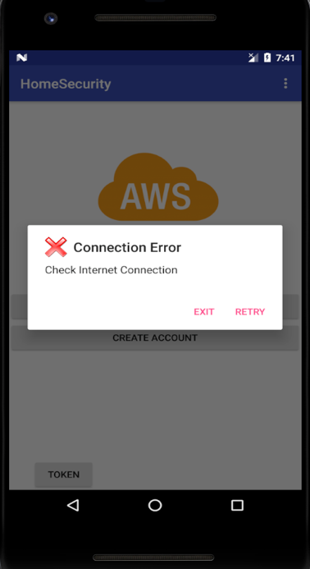

Code snippet:

*//Check internet access if no connectivity display alert window***if**(!isNetworkAvailable()){  
 *//Create alertdialog* AlertDialog.Builder Checkbuilder = **new** AlertDialog.Builder(MainActivity.**this**);  
 Checkbuilder.setIcon(R.drawable.***error***);  
 Checkbuilder.setTitle(**"Connection Error"**);  
 Checkbuilder.setMessage(**"Check Internet Connection"**);  
 *//Builder Retry Button* Checkbuilder.setPositiveButton(**"Retry"**, **new** DialogInterface.OnClickListener() {  
 @Override  
 **public void** onClick(DialogInterface dialog, **int** which) {  
 *//Restart the Activity* Intent intent = getIntent();  
 finish();  
 startActivity(intent);  
 }  
 });

Checkbuilder.setNegativeButton(**"Exit"**, **new** DialogInterface.OnClickListener() {  
 @Override  
 **public void** onClick(DialogInterface dialog, **int** which) {  
 finish();  
 }  
});  
  
AlertDialog alert = Checkbuilder.create();  
alert.show();

**private boolean** isNetworkAvailable(){  
 ConnectivityManager connectivityManager = (ConnectivityManager)**this**.getSystemService(Context.***CONNECTIVITY_SERVICE***);  
 NetworkInfo activeNetworkInfo = connectivityManager.getActiveNetworkInfo();  
 *//return true or false based on connection* **return** activeNetworkInfo != **null**;  
}

### Integration with Parse Server

Another very interesting option of the application is the ability to create accounts and verify already registered users. This feature could be used in larger projects, where you ned to manage large number of users.

This feature required setting up services in the cloud and configuring the application. Required configuration steps will be described below. Official documentation is available in references section [3].

The first step was to log in to the AWS EC2 console and start the t2.micro instance, which is free. Next step was to launch Parse Server from the Amazon marketplace to generate and retrieve security keys.

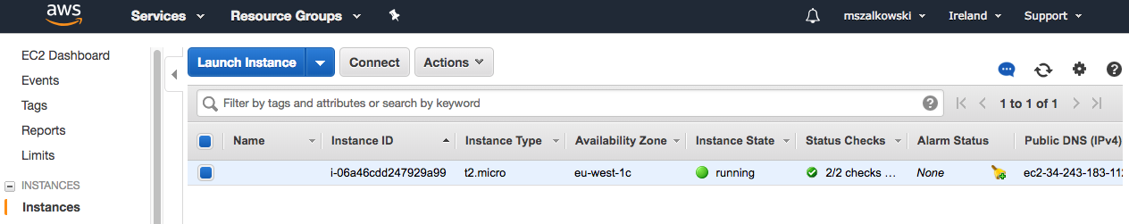

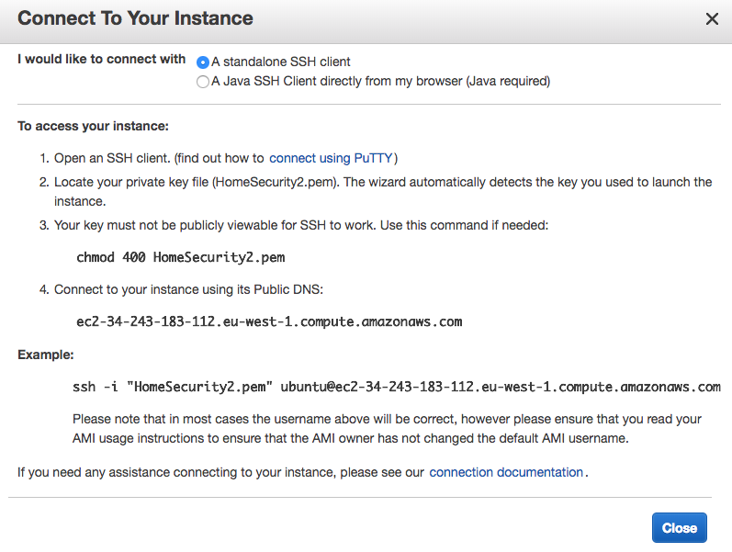

After saving the keys on the device, it was required to connect via ssh and finish configuring the Parse Server. Once completing the configuration, I received the application id, the client key and the URL of the server on which the Parse Server operates. After entering the URL in the browser, a name and password were required. This information had to be extracted from the EC2 logs.

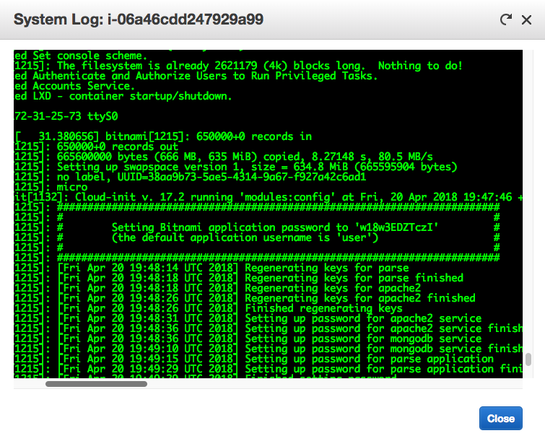

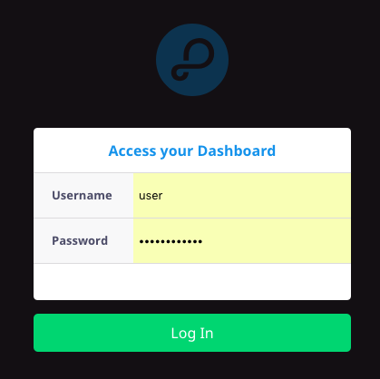

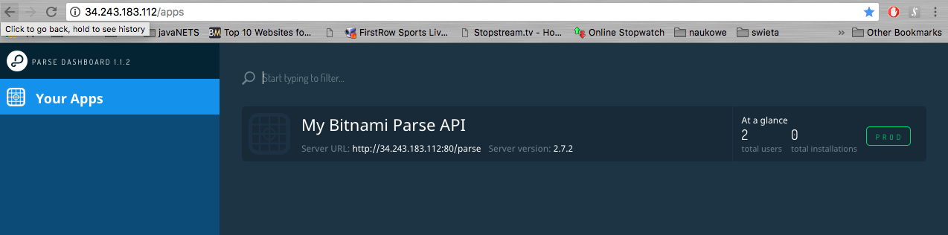

The next part describes the steps required to set up the mobile application.

This class starts first and extending it to the application guarantees access to data from each activity.

**public class** StartApplication **extends** Application {  
 @Override  
 **public void** onCreate() {  
 **super**.onCreate();  
  
 Parse.*initialize*(**new** Parse.Configuration.Builder(**this**)  
 .applicationId(**"7726b23decb442e13396796a733f868f40c8b651"**)  
 .clientKey(**"351680d565fbcb4c27f0e7b441c132628d9a39d8"**)  
 .server(**"http://34.243.183.112:80/parse"**)  
 .build()  
 );  
 }  
}

The next two snippets show the steps required to create a user and log on to the server. If the fields are left blank, an error message appears.

**private void** createAccount(){  
 **final** String name = **userName**.getText().toString();  
 **final** String password = **userPassword**.getText().toString();  
  
 **if** (name.equals(**""**) || password.equals(**""**)){  
 **final** AlertDialog.Builder dialog = **new** AlertDialog.Builder(CreateAccount.**this**);  
 dialog.setTitle(**"Empty fields"**);  
 dialog.setMessage(**"Please complete the form"**);  
 dialog.setPositiveButton(**"OK"**, **new** DialogInterface.OnClickListener() {  
 @Override  
 **public void** onClick(DialogInterface dialog, **int** i) {  
 dialog.dismiss();  
 }  
 });  
 dialog.show();  
 }  
 **else**{  
  
 ParseUser user = **new** ParseUser();  
 user.setUsername(name);  
 user.setPassword(password);  
 user.signUpInBackground(**new** SignUpCallback() {  
 @Override  
 **public void** done(ParseException e) {  
 **if** (e == **null**){  
 **createAccount**.setEnabled(**false**);  
 **userName**.setEnabled(**false**);  
 **userPassword**.setEnabled(**false**);  
  
 *//log them in* logUserIn(name, password);  
 }  
 }  
 });  
 }  
}  
  
**private void** logUserIn(String name, String password) {  
 **if** (!name.equals(**""**) || !password.equals(**""**)){  
 ParseUser.*logInInBackground*(name, password, **new** LogInCallback() {  
 @Override  
 **public void** done(ParseUser user, ParseException e) {  
 **if** (e == **null**){  
 Log.*v*(**"User logged in"**, user.getUsername());  
 startActivity(**new** Intent(CreateAccount.**this**, MQTTActivity.**class**));  
 }  
 **else** {  
  
 Log.*i*(***TAG***, **"error"**);  
  
 }  
 }  
 });  
 }  
 **else** {  
 Log.*i*(***TAG***, **"connection issue"**);  
 }  
}

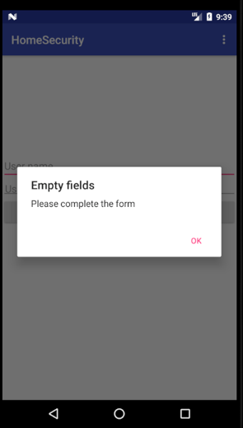

**logIn**.setOnClickListener(**new** View.OnClickListener() {  
 @Override  
 **public void** onClick(View view) {  
 String name = **userName**.getText().toString();  
 String password = **userPassword**.getText().toString();  
  
 **if** (!name.equals(**""**) || !password.equals(**""**)){  
 ParseUser.*logInInBackground*(name, password, **new** LogInCallback() {  
 @Override  
 **public void** done(ParseUser user, ParseException e) {  
 **if** (e == **null**) {  
  
 Toast.*makeText*(getApplicationContext(), **"Login Successfully!"** , Toast.***LENGTH_LONG***).show();  
  
 startActivity(**new** Intent(Login.**this**, MQTTActivity.**class**));  
  
 }**else** {  
  
 Toast.*makeText*(getApplicationContext(), **"Not logged in"**,  
 Toast.***LENGTH_LONG***).show();  
  
 }  
 }  
 });  
 }  
 **else** {  
 Toast.*makeText*(getApplicationContext(), **"Please enter username and Password"**,  
 Toast.***LENGTH_LONG***).show();  
 }  
  
 }  
});

New and existing users can be managed directly from the Parse Server Dashboard.

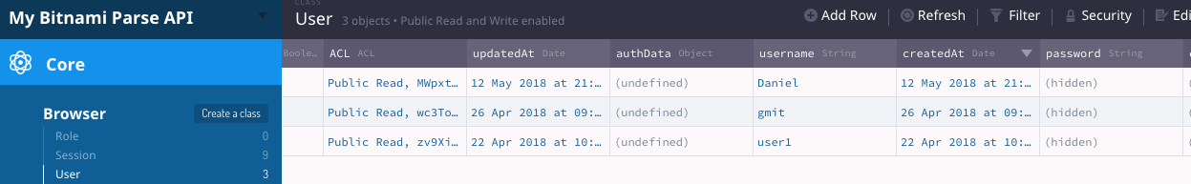

### Integration with AWS IoT

To implement this feature I had to re-use ready-made examples provided by AWS [4]. In this section, I will describe the changes that I have made to improve functionality and connectivity with other elements.

This part required to create another certificate and key from the Cognito Identity AWS service. Enabling access to unauthenticated identities and creating more roles in Identity and Access Management IAM.

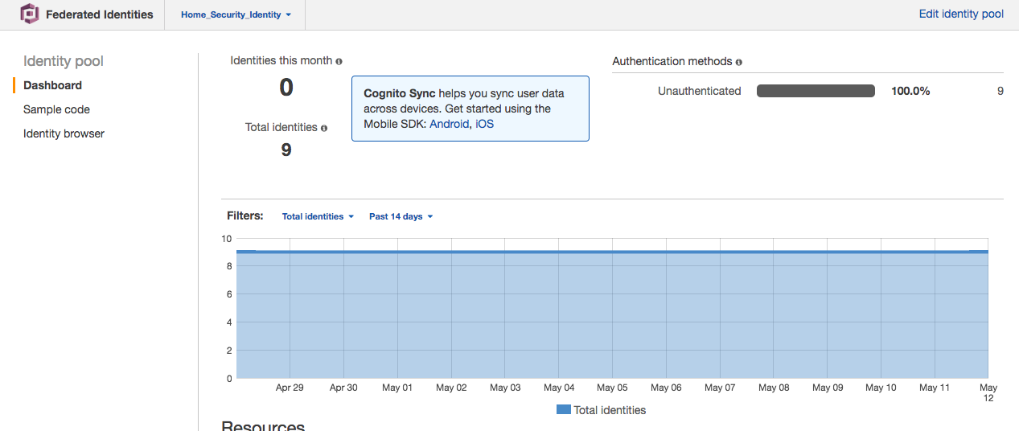

To run the demo, it is necessary to read the keys, certificates and other security files. Since there are two examples integrated in the project, I had to find a solution for efficient and safe reading of this data. Initially, the data was read from the JSON file. However, while developing the project, I worked on different versions of the Android system and on each data read process was different. Therefore, I decided to use one class with all constant data. Which was ignored by GIT to ensure security.

Code snipped below:

**public class** Constants {  
  
 **public static final** String ***CUSTOMER_SPECIFIC_ENDPOINT*** = **"a2gs -1. "**;  
 **public static final** String ***COGNITO_POOL_ID*** = **"eu-west-1:5ee5"**;  
 **public static final** String ***AWS_IOT_POLICY_NAME*** = **"Policy"**;  
 **public static final** String ***KEYSTORE_NAME*** = **"keystore"**;  
 **public static final** String ***KEYSTORE_PASSWORD*** = **"password"**;  
 **public static final** String ***CERTIFICATE_ID*** = **"default"**;  
 **public static final** Regions ***COGNITO_REGION*** = Regions.***EU_WEST_1***;  
 **public static final** String ***TEST_TABLE_NAME*** = **"Temperature"**;  
 **public static final** Regions ***DYNAMODB_REGION*** = Regions.***EU_WEST_1***;  
}

The link to the code to connect to AWS IoT is in the references below. I will discuss some of the elements required to communicate with AWS IoT

This snippet represents some of the steps required to connect to the AWS IoT.

*clientManager* = **new** AmazonClientManager(**this**);  
  
*// Initialize the AWS Cognito credentials provider***credentialsProvider** = **new** CognitoCachingCredentialsProvider(  
 getApplicationContext(), *// context* Constants.***COGNITO_POOL_ID***, *// Identity Pool ID  
 MY_REGION // Region*);  
  
Region region = Region.*getRegion*(*MY_REGION*);  
*// MQTT Client***mqttManager** = **new** AWSIotMqttManager(**clientId**, Constants.***CUSTOMER_SPECIFIC_ENDPOINT***);  
*// Set keepalive to 10 seconds. Will recognize disconnects more quickly but will also send  
// MQTT pings every 10 seconds.***mqttManager**.setKeepAlive(10);  
  
*// Set Last Will and Testament for MQTT. On an unclean disconnect (loss of connection)  
// AWS IoT will publish this message to alert other clients.*AWSIotMqttLastWillAndTestament lwt = **new** AWSIotMqttLastWillAndTestament(**"my/lwt/topic"**,  
 **"Android client lost connection"**, AWSIotMqttQos.***QOS0***);  
**mqttManager**.setMqttLastWillAndTestament(lwt);  
  
*// IoT Client (for creation of certificate if needed)***mIotAndroidClient** = **new** AWSIotClient(**credentialsProvider**);  
**mIotAndroidClient**.setRegion(region);  
  
**keystorePath** = getFilesDir().getPath();  
**keystoreName** = Constants.***KEYSTORE_NAME***;  
**keystorePassword** = Constants.***KEYSTORE_PASSWORD***;  
**certificateId** = Constants.***CERTIFICATE_ID***;

After establishing a connection, you can use the buttons in the application to send messages that are later read and processed by Raspberry Pi to control devices.

@Override  
**public void** onClick(View view) {  
  
 *//Topics on the MQTT side to control devices.* **final** String topic_led = **"mytopic/iot/led"**;  
 **final** String topic_heater = **"mytopic/iot/heat"**;  
  
 **switch** (view.getId()) {  
  
 **case** R.id.***deviceON***:  
  
 **try** {  
 **mqttManager**.publishString(**"on"**, topic_led, AWSIotMqttQos.***QOS0***);  
 } **catch** (Exception e) {  
 Log.*e*(***LOG_TAG***, **"Publish error."**, e);  
 }  
 **break**;  
 **case** R.id.***deviceOFF***:  
  
 **try** {  
 **mqttManager**.publishString(**"off"**, topic_led, AWSIotMqttQos.***QOS0***);  
 } **catch** (Exception e) {  
 Log.*e*(***LOG_TAG***, **"Publish error."**, e);  
 }  
 **break**;

}

Published messages are sent to the MQTT broker, pushed to Raspberry Pi and processed to perform a specific action. The following snippet shows how easily it is to control the LED using this method.

# wait for a message from aws console topic.

def onm(c, userdata, msg):

m = msg.payload.decode()

print(m)

if m == 'on':

GPIO.output(led_device, GPIO.HIGH)

elif m == 'off':

GPIO.output(led_device, GPIO.LOW)

### Retrieving temperature value from DynamoDB

To carry out this part of the project another example of AWS was used, thanks to that it was possible to read the temperature. The example has been modified so that it could work with this project [5].

The code below shows the implementation of previously developed data storage algorithm in the database. As you remember, this has been saved as a pair of key data. Where the time value was recorded in milliseconds and temperature as a number. To read the latest temperature a Java HashMap was used to which all values form the database were saved. Then stored using Java List interface, saved in the array, and thus the last element of the index is displayed on the application screen after pressing the button

**private class** GetUserListTask **extends** AsyncTask<Void, Void, Void> {  
 **protected** Void doInBackground(Void... inputs) {  
 **labels** = **new** ArrayList<String>();  
 **items** = DynamoDBManager.*getTemperature*();  
 Map<Double, String> map = **new** HashMap<Double, String>();  
 **for** (DynamoDBManager.UserPreference up : **items**) {  
 Double key = **new** Double(up.getMillis());  
 String value = **new** String(up.getDBTemperature());  
 map.put(key, value); }  
  
 **for** (Double name: map.keySet()){  
 String key = name.toString();  
 String value = map.get(name).toString();  
 Log.*i*(***LOG_TAG***, key+**" "**+ value);  
 }  
  
 List keys = **new** ArrayList(map.keySet());  
 Collections.*sort*(keys);  
 Log.*i*(***LOG_TAG***, **" "**+ keys);  
 **int** index = keys.size()-1;  
 String latestDBentry = keys.get(index).toString();  
 **double** latestToDouble = Double.*parseDouble*(latestDBentry);**final** String toUI = map.get(latestToDouble);  
 Log.*e*(***LOG_TAG***, **""**+toUI);  
  
 runOnUiThread(**new** Runnable() {  
 @Override  
 **public void** run() {  
 **dynamoDBText**.setText(toUI);  
 }  
 });  
  
 **return null**;  
 }  
}

### Integration with Google Firebase and receiving notifications.

This structural feature was the most complicated and one of the most difficult to implement. It requires description of the operation of individual elements and explanation of steps related to their connection.

Let’s start with a brief discussion about the entire operation of this element. When new items appear in the S3 container e.g. photo or other object, the cloud activates Lambda function. The lambda function executes the code stored in the cloud, which captures the URL link of the new element on S3. Lambda activates Simple Notification Service SNS and sends a link of this object in the message to SNS. In the next phase, the SNS adds a token to that message. The token is assigned to the application and required by Google servers. Message is sent then the message is sent to the google Firebase server and the token is verified there. After positive verification, the application receives a push notification with a link to the photo taken with the Raspberry Pi camera.

Steps will be chronologically discussed to describe events.

The creation and configuration of the S3 bucket has been discussed earlier. The Lambda function had to be created and configured to receive notifications of new S3 elements. For this purpose, it was required to add an access permissions policy in IAM service, to invoke the Lambda function only, for object-created event from a specific bucket that is owned by a specific AWS account. Below is an example of permissions configuration that must be included in the Lambda function when it is created. This ensures that the function will be performed only in the event of a new element appearing on the S3 and the ability to communicate with the SNS.

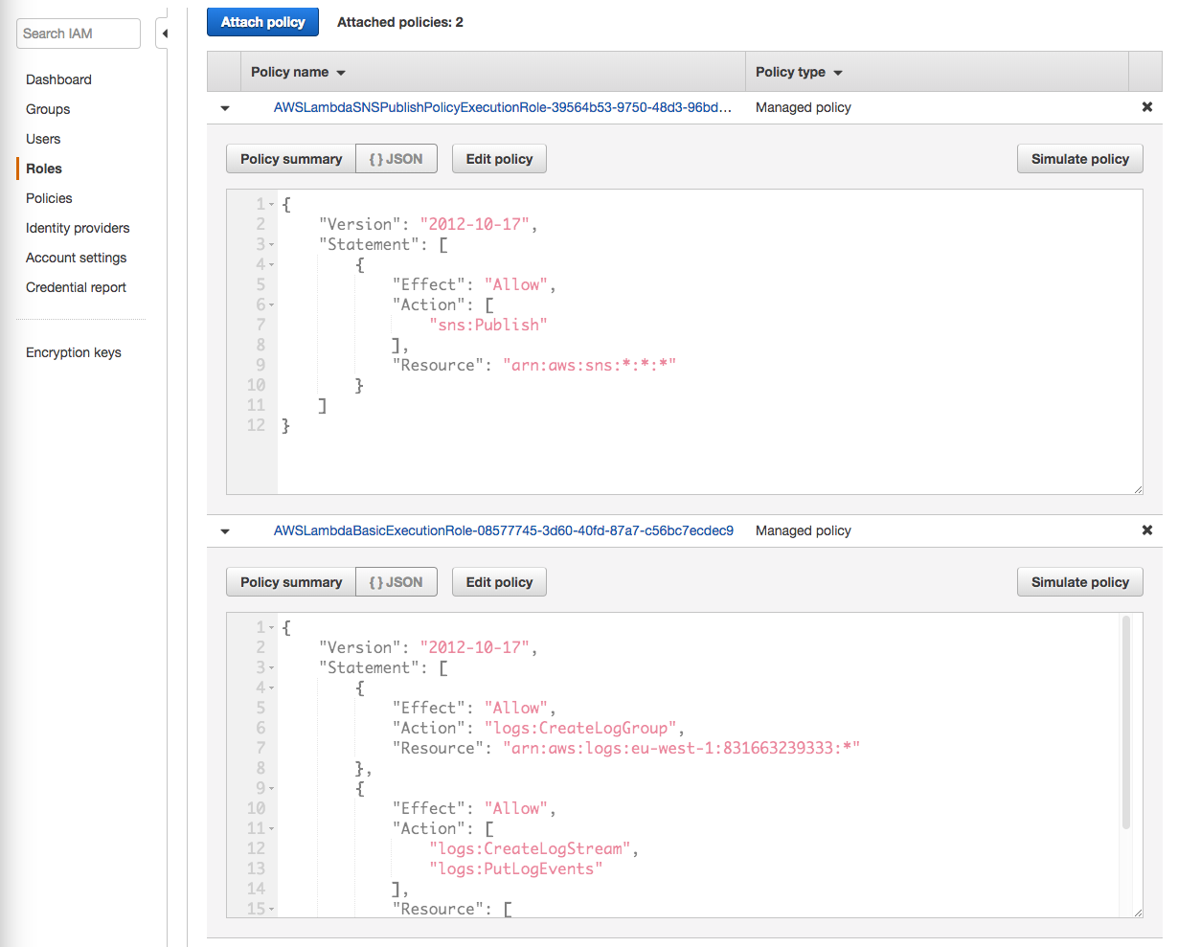

The next step was to add permission to the bucket event.

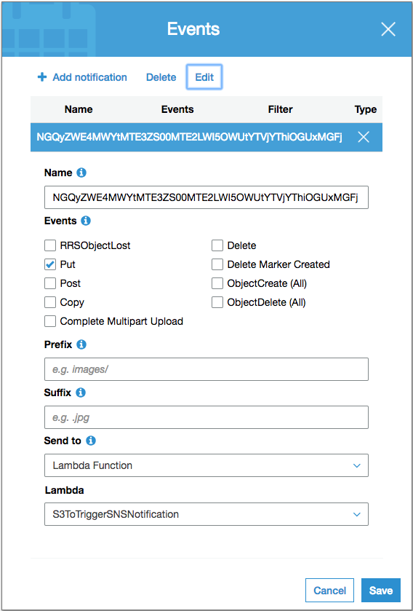

This was the last step taken during the configuration. The following screenshot allows a visual understanding of the events.

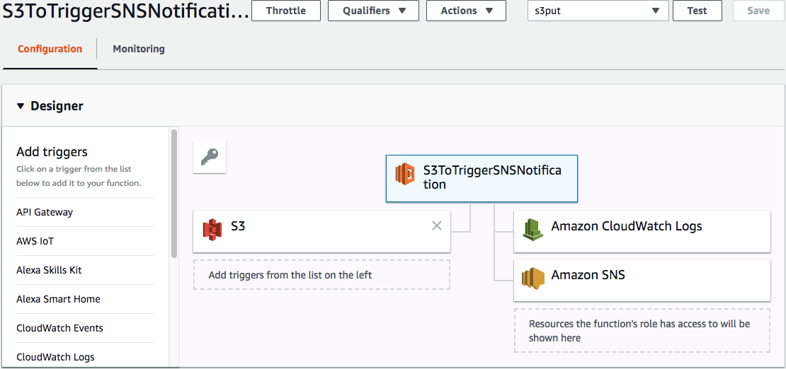

This section describes the code used to extract the URL for the new S3 object. A great merit goes to the user of the stackoverflow forum named dpwrussell [6], who led me through the debugging process. Without this help, I would not be able to complete this function before the demonstration day. Thank you again for your help! This lesson taught me that the elements written on S3 are sent as a JSON object and to obtain such an object and information about it, it was necessary to correctly read elements from the JSON object in Lambda function.

from __future__ import print_function

import logging

import boto3

import json

from botocore.client import Config

#logger used for visual debugging only

logger = logging.getLogger()

logger.setLevel(logging.INFO)

sns = boto3.client('sns')

s3 = boto3.client('s3')

# main lambda executing function

def lambda_handler(event, context):

# retrieve bucket name and file_key from the S3 event

bucket_name = event['Records'][0]['s3']['bucket']['name']

print(bucket_name)

file_key = event['Records'][0]['s3']['object']['key']

print(file_key)

print('this will also show up in cloud watch')

logger.info('got event{}'.format(bucket_name))

logger.info('got event{}'.format(file_key))

presigned_url = s3.generate_presigned_url(

ClientMethod='get_object',

Params = {

'Bucket': bucket_name,

'Key': file_key

}

)

sns.publish(

TargetArn='arn:aws:sns:eu-west-1:831663239333:HomeSecurityApp',

Message=presigned_url

)

And this was the sample JSON object for testing which, I wrote during debugging process:

{

"Records": [

{

"s3": {

"bucket": {

"name": "homesecurityforpi"

},

"object": {

"key": "ExampleCloudTrailLog.json.gz"

}

}

}

]

}

The next part will discuss the configuration of the Google Firebase.

The initial step required creating a new project in Google Firebase, resulting in obtaining a server and legacy keys. Necessary to configure the Amazon SNS service [7].

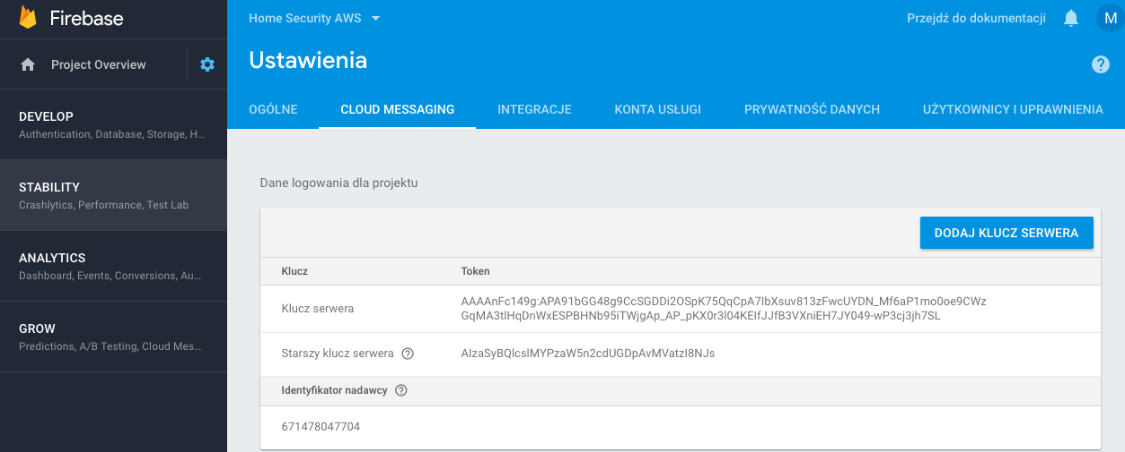

The next step was to move to Amazon SNS and adding information about to which mobile application push notifications will be sent. The configuration required the server key generated in the previous step.

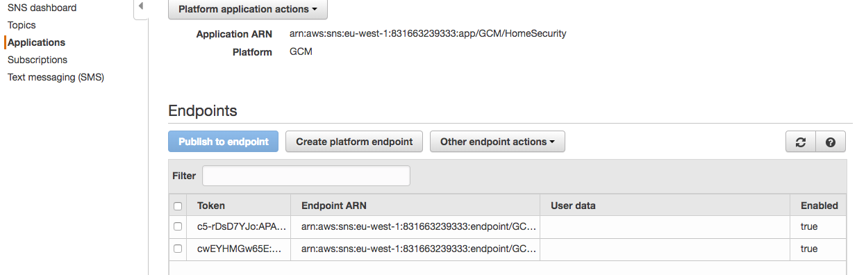

The next step was to configure the application to obtain the token required by the Google server. Prior to this, it was required to synchronize the project with Google services via adding the google-services.json file to the Android project. This file contained detailed information, such as keys and identifiers required to enable notifications.

A fragment of the Firebase code below to generate the platform endpoint token:

**public class** FireBaseInstance **extends** FirebaseInstanceIdService {  
 **private static final** String ***TAG*** = **"MyFirebaseInsIDService"**;  
  
 @Override  
 **public void** onTokenRefresh() {  
 **super**.onTokenRefresh();  
 String refreshtoken = FirebaseInstanceId.*getInstance*().getToken();  
 Log.*d*(***TAG***, **"New token"**+refreshtoken);  
 }  
}

After receiving the code, the last part of this configuration was to add it to the Amazon SNS:

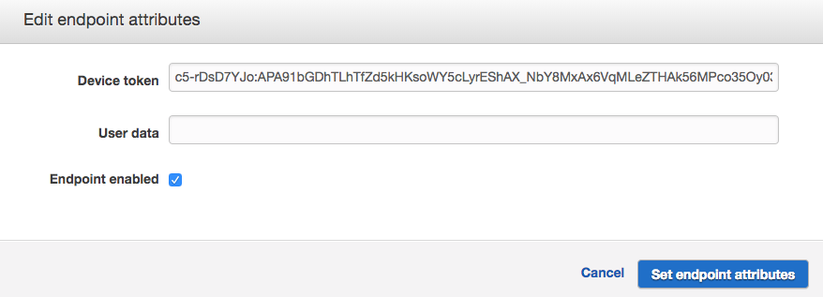

Amazon SNS has already been fully configured with Google Firebase and ready to send notifications to the mobile application. The last step was to write the code that displayed the notification on the phone, and capture the image sent via push notification. The format of the push message was received in the form of JSON message e.g. {default=”S3 image URL”}. A simple sub-string algorithm was used to capture the URL address and to download the image directly.

**public class** FireBaseMessage **extends** FirebaseMessagingService {  
  
 **private static final** String ***TAG*** = **"MsgService"**;  
  
 @Override  
 **public void** onMessageReceived(RemoteMessage remoteMessage){  
 Log.*d*(***TAG***, **"FROM"**+ remoteMessage.getFrom());  
  
 **if** (remoteMessage.getData().size() > 0) {  
 Log.*d*(***TAG***, **"Message data: "**+ remoteMessage.getData());  
 String str = remoteMessage.getData().toString();  
 **int** length = str.length();  
 Log.*e*(***TAG***, **"Message data: "**+str.substring(9, length-1));  
 String url = str.substring(9, length-1);Intent intent = **new** Intent(Intent.***ACTION_VIEW***);  
 intent.setFlags(Intent.***FLAG_ACTIVITY_CLEAR_TOP***);  
 intent.setData(Uri.*parse*(url));  
 *//startActivity(intent);* PendingIntent pendingIntent = PendingIntent.*getActivity*(**this**, 0, intent, PendingIntent.***FLAG_ONE_SHOT***);  
  
 Uri notificationSound = RingtoneManager.*getDefaultUri*(RingtoneManager.***TYPE_NOTIFICATION***);  
 NotificationCompat.Builder notifBuilder = **new** NotificationCompat.Builder(**this**)  
 .setSmallIcon(android.R.mipmap.***sym_def_app_icon***)  
 .setContentTitle(**"Home Security Notification"**)  
 .setContentText(remoteMessage.getData().toString())  
 .setAutoCancel(**true**)  
 .setSound(notificationSound)  
 .setContentIntent(pendingIntent);  
  
 NotificationManager notifyManager = (NotificationManager) getSystemService(Context.***NOTIFICATION_SERVICE***);  
 notifyManager.notify(0*/*ID of notification*/*, notifBuilder.build());  
 }  
 }  
}

# Conclusion

## Problems Encountered

While creating this project, I encountered several problems that I had to solve. It was a very interesting experience and it certainly taught me new skills that I will be able to use in my future career. Problems during the creation of the project resulted mainly from the lack of experience and knowledge in the area that I undertook.

I will try to list all the important problems encountered during this project and explain briefly how they were solved.

* First contact with Amazon AWS and simple “hello world”
* Integrating provided Android mobile applications
* Extracting URL’s from pictures stored to S3

**First contact with Amazon AWS and simple “hello world”**

I can honestly say that the first contact with Amazon AWS was quite difficult and frustrating at the same time. This is because it was my first contact with cloud computing technology. In college, we covered the theoretical foundations of AWS, and this knowledge helped me in choosing AWS services appropriate for the development of the project.

As you probably already know, after reading the previous chapters on cloud configuration, this requires configuring many different settings and permissions. This can be quite difficult for beginners, and documentation is not always clear.

Coming back to the problem. It took me a good few days to connect Raspberry Pi with the AWS IoT console. For this reason, I was blocked with further progress of work. At one point, I was considering temporarily suspending AWS, and using a local server to focus on further development. Fortunately, after a few days break and re-attempts to connect the IoT console, I was successful. It was a breakthrough that motivated me further and gave me hope for a positive end to this project.

**Integrating provided Android mobile applications**

Because to create a mobile application I had to use the examples provided by Amazon. An additional problem was that they were written by someone else, and each had to be ripped apart and understood, and only then I could start adding elements needed for my project. I have put in a lot of work, but it seems to me that the writing applications from the scratch seems to be more satisfying. I am also convinced that thanks to this I would learn more.

**Extracting URL’s from pictures stored to S3**

Similarly to the first problem, most of the elements used in the project were completely new. I admit that learning and programming in Python was pleasure and I regret that it was not in the college program. Nevertheless, at the last stage of the project, I did not know how to extract the link from the new S3 object. Fortunately, there is a great Q&A forum in which programmers can ask questions related to programming problems. I asked a question and one of the stackoverflow users led me through the error debugging process I encountered. Thanks to this help I was able to understand and introduce this feature the project.

## Goals achieved

Initially, I worked on a different project but had difficulties making progress with it. I had to make the tough decision to change projects at a late stage knowing I would only have half the time to complete it. As the work completed on the first project could not be reused, I found it was challenging to complete this project with limited time. However the project was successfully integrated and all basic AWS services were implemented.

The most important features of the projects are:

* Connection with AWS IoT console
* Sending and receiving IoT messages via MQTT protocol
* Storing temperature values to DynamoDB database
* Storing pictures to S3 container
* Controlling devices connected to Raspberry Pi via mobile phone
* Setting up temperature of heating system and remote heat control
* Receiving notifications from Google Firebase when alarm is triggered
* Pulling latest temperature value from DynamoDB to mobile application
* Receiving pictures from security camera to mobile application
* Creating new user accounts with Parse Server

## Goals not achieved

I had plans to add live streaming from Pi camera to mobile application. Unfortunately, there was no time for this because the functions mentioned above required further work up to the project demonstration itself. This is a certainly a feature that I will want to add during the further development of the project.

Another unfinished goal was to integrate the S3 bucket with the mobile application instead of sending photos as links to URLs. It is a design element that may appear in the future and will be designed and implemented to increase the convenience of using the application.

The last element that I have not perfected is the application’s user interface. It is a plain interface but missing appealing elements. Professional applications have many eye-catching elements and it is good practice to follow these trends.

## Final conclusion

We all live in a world that is filled with the latest technologies. In the last thirty years, the greatest progress has been made in the field of computer science. Artificial intelligence and self-driving are becoming today’s standards. Almost every one of us is connected to some form of social media. Today’s smartphones have a similar performance to PC’s and people use them as tools for work and entertainment. Interestingly, people today cannot imagine life without them. Over the years, our approach to technology has changed and today it is more at our fingertips. Unfortunately, the lurking threats remain unchanged and each of us can fall victim. Technologies should be used to improve our safety and comfort. This project aims to offer a home security solution with home automation elements.

It is worth emphasizing the importance of the home security project. Certainly consists of more than one benefit: immediate user notifications, remote access to connected devices, the ability to control the heating system, ease to use interface and low cost implementation.

From building this project I have gained experience related to cloud computing, development of Android and Python programming language. Also I improved the ability to manage time and solve problems.

If I were to start this project again I would integrate more AWS services and focus more on user interface.

To sum up everything I can clearly say, this project has been a successful and I am proud of it. Of course, every development requires corrections and improvements. In my case it is the same. I will continue to work on this system as a hobby.

# 9. References

|  |  |
| --- | --- |
| [1] | AWS. [Online]. Available: https://docs.aws.amazon.com/iot/latest/developerguide/iot-sdk-setup.html. |
| [2] | F. Hilitski. [Online]. Available: http://www.fhilitski.com/2016/11/temperature-sensor-with-raspberry-pi-3-and-aws/. |
| [3] | Parse. [Online]. Available: http://docs.parseplatform.org/android/guide/. |
| [4] | [Online]. Available: https://github.com/awslabs/aws-sdk-android-samples/tree/master/AndroidPubSub. |
| [5] | [Online]. Available: https://github.com/awslabs/aws-sdk-android-samples/tree/master/DynamoDBMapper_UserPreference_Cognito. |
| [6] | [Online]. Available: https://stackoverflow.com/questions/50089442/aws-s3-lambda-sns-how-to-send-url-link-with-new-image-to-android-app. |
| [7] | [Online]. Available: https://firebase.google.com/docs/android/setup. |

# Source code

<https://github.com/matszal/FYP>

<https://github.com/matszal/Android_App_4_FYP/tree/master/HomeSecurity2>